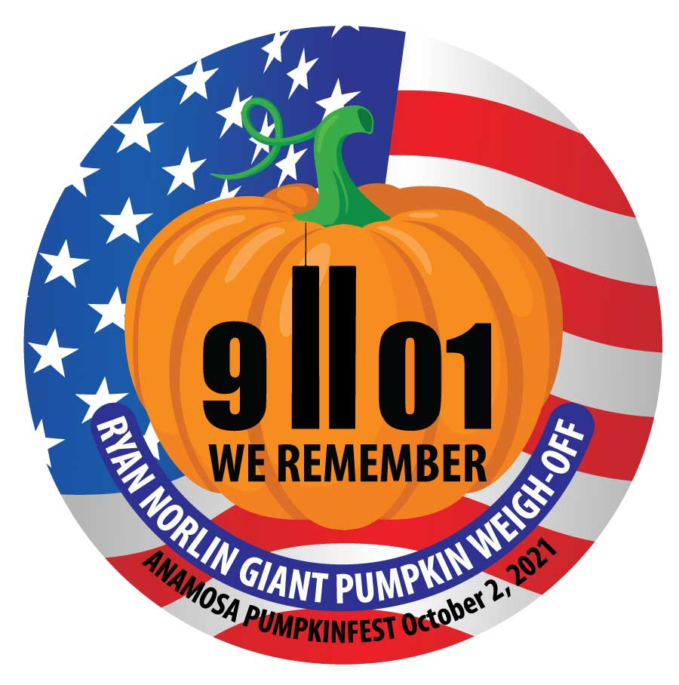
Friends of Pumpkinfest,

Planning is underway for the 2021 Anamosa Pumpkinfest and Ryan Norlin GIANT Pumpkin Weigh-Off!
Since the Weigh-Off began in 1989, it has drawn thousands of visitors to town every year. In 1993, Anamosa was officially designated the Pumpkin Capital of Iowa. In 2020, despite the pandemic and many cancelled activities, Anamosa weighed a new state record squash, 1,326.5 lbs., and a new site record pumpkin, 2,114 lbs. At the first Weigh-Off in 1989, the winning pumpkin was 253lbs; we have really come a long way!

This year, Pumpkinfest is back, along with many of your favorites: Craft and Food Vendors, 5K Run/Walk, Big Wheel Races, Kids’ Games, Chili Cook-Off, our HUGE Parade, and many more. We are also excited to have the Car Show return and announce we are adding a Petting Zoo!

With your support, we can build on tradition and Pumpkinfest will continue to be a true Main Street Festival. Donations may be made to Anamosa Festivals, a 501(C)(3) recognized by the IRS as tax deductible. Also, payment may be sent via Venmo: @Anamosa-Chamber and note Pumpkinfest Sponsorship and Your Name as you would like it to appear on marketing material.

Sponsor Name: ______________________________________________________

Sponsorship: $_____________________

Thank you for your continued support!
Anamosa Pumpkinfest Committee:
Greg & Nancy Norlin, Doug Edel, Katie Gombert, Angela Winekauf, Bobby Krum, Shannon Frink, Rozy Warder &
LeeAnna Boone (Anamosa Chamber Director)

***Sponsorships received after September 10th are not guaranteed all benefits***

Anamosa Chamber of Commerce • 213 East Main Street, Anamosa, IA 52205 • 319-462-4879
Sponsorship Levels:

Platinum ($1,000+):
- Recognition at the Parade
- Logo on the Thank You Banner outside the Weigh-Off and Anamosa Chamber Office
- Logo on slideshow at Weigh-Off
- Pumpkinfest Golf Tournament Hole Sponsorship
- Logo on Website & in the Chamber Newsletter
- Facebook recognition

Gold ($500-$999):
- Bold Name on the Thank You Banner outside the Weigh-Off and at Anamosa Chamber Office
- Bold Name on slideshow at Weigh-Off
- Pumpkinfest Golf Tournament Hole Sponsorship
- Logo on Website & in the Chamber Newsletter
- Facebook recognition.

Silver ($250-$499):
- Name on the Thank You Banner outside the Weigh-Off and Anamosa Chamber Office
- Pumpkinfest Golf Tournament Hole Sponsorship
- Name in the Chamber Newsletter
- Facebook recognition

Bronze ($100-$249):
- Pumpkinfest Golf Tournament Hole Sponsorship
- Name in the Chamber Newsletter
- Facebook recognition.

Friends ($25-$99):
- Name in the Chamber Newsletter
- Facebook recognition

***Sponsorships received after September 10th are not guaranteed all benefits***

Please email logo files to: director@anamosachamber.org
Venmo @Anamosa-Chamber
Or mail to:
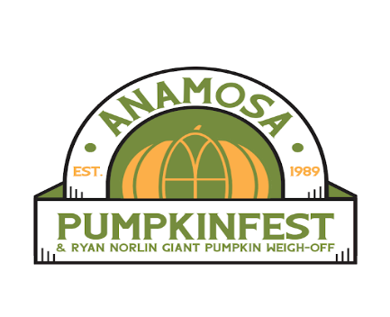
Anamosa Chamber of Commerce • 213 East Main Street, Anamosa, IA 52205 • 319-462-4879
www.anamosachamber.org

