Anamosa Pumpkinfest Chili Cook-Off
Saturday, October 2nd,2021
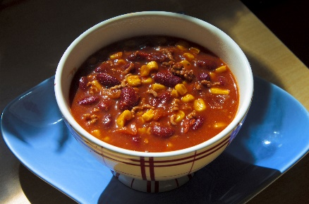
All proceeds go to the food pantry!
Cooks Need:
- Table (preferably heavier than a card table) – to be set up any time after 9:00 am
- Cooking Utensils- to include a serving spoon, apron (if desired), potholders, dish rag for wiping up spills, small pail of water to wash hands, paper towels, small waste basket.
- Crockpot-electricity will be available for pots no bigger than a crock pot, please bring an extension cord
- Box of Saltine Crackers
Instructions:
- Location- Fareway store (Anamosa)
- Chili needs to be cooked at home
- Anything goes for ingredients
- Chili needs to be ready to serve in taster cups at 10am
- Tasting will go from 11-1 with clean up to follow
- Taster cups will be sold at a price based on number of participants. Tasters may sample chili from each booth
- Chili dogs will be sold for $3 each
- Chili Tasters will judge in 1 category, “Best tasting chili”
- Winner will receive a $25 gift certificate to Fareway
- Entry fee of $5 – all proceeds go to the Anamosa Food Panty!

Taster cups, small spoons, chili dog sandwich boats, napkins, hot dogs, and buns will be furnished!

