
14th Annual
Pumpkinfest 5K Run/Walk

Date: Saturday, Oct 2nd, 2021
Registration Time: 8:00-8:45 a.m.
Start Time: 9:00 a.m.

Location: Jones County Courthouse Main Street Anamosa

Course:
Main Street to Scott St and out on Shaw Road: The Jones County Wapsipinicon Trail!

Registration:
Mail Registration to:
Anamosa Pumpkinfest 5K
Attn: Nic Weers
215 East Main St.
Anamosa, IA 52205

Or online at: GetMeRegistered.Com
* (fee applies)

Cost: $10.00 age 19 & Under
$15.00 age 20 & Older
$20.00 all registrants after Sept. 20th & Race Day

Make Checks Payable to:
Anamosa Pumpkinfest 5K



14th Annual Pumpkinfest 5K Run/Walk is hosted by:

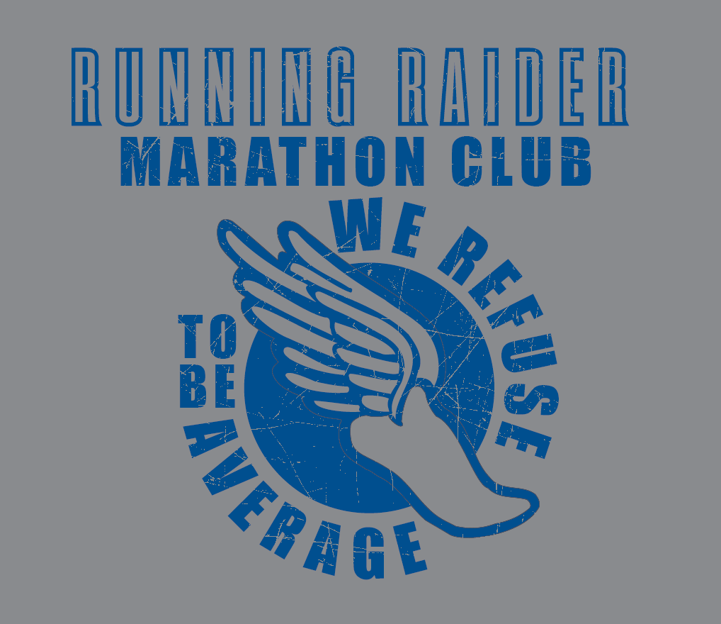

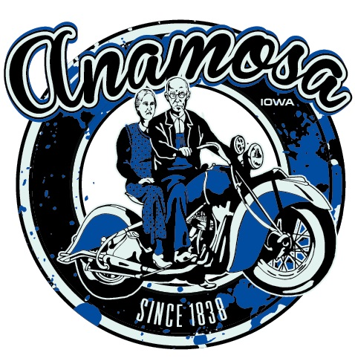
Anamosa Chamber of Commerce
www.anamosachamber.org
(319) 462-462-4879
Email: director@anamosachamber.org

Questions:

Contact:
Nic Weers (Race Coordinator)
319-462-3561
nweers@citizensbankia.com

Registration Form

14th Annual Pumpkinfest
5K Run/Walk

Name:

Address:

City/State/Zip:

Phone:

Age As of 10/2/2021:

Sex:

Parent/Guardian:

Email:

Shirt Size: YS YM YL S M L XL XXL

In consideration of being allowed to participate in the Pumpkinfest 5K Run/Walk, the undersigned acknowledges, appreciates, and agrees that: There exists a risk of injury. The Pumpkinfest 5K Run/Walk and its coordinators, helpers and any of their affiliates including the City of Anamosa and the County of Jones State of Iowa, are neither liable nor responsible for a medical or hospital bill occurring as a result of injuries sustained by the registered person while participating in the Pumpkinfest 5K Run/Walk. All injury related expenses shall be the responsibility of the participant or the participant’s parent/legal guardian. Please sign below if you agree to the conditions stated above.

Signature Date

If under 18, signature of parent or guardian is required.

Award Divisions
Boys & Girls
Men & Women
8 & Under
9-12
13-15
16-19
20-29
30-39
40-49
50-59
60 & Older

- Award Ceremony begins after last participant has completed the run/walk
- Trophies to 1st place age and gender division winners ages 15 & Under
- Medals to top 3 of all age divisions and genders

Aid Station
Water will be provided at the start, 1.5 mile marker and the finish. Refreshments will also be provided at the finish.

Showers
Free and clean showering facilities are available at the Lawrence Community Center for all registrants.

Early Packet Pick-Up
Race packets can be picked up on
Friday, October 1st at Citizens Bank, from 9-4 PM. Packets will also be available the morning of the race at the registration tent by the start line.
14th^{th} Annual Pumpkinfest 5K Run/Walk



